PUZZLES OF DEMOLITION OF PAWN STRUCTURE

1. White mates/ Black mates
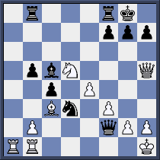

W:

B:

2. White wins/ Black wins
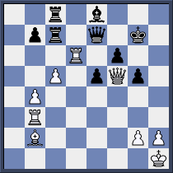

W:

B:

3. White mates/ Black wins
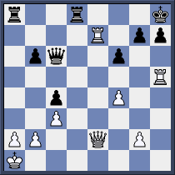

W:

B:

4. White mates/ Black to win
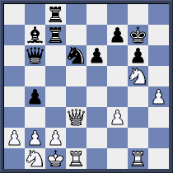

W:

B:

5. White mates/ Black mates
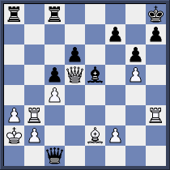

W:

B:

6. White mates/ Black mates
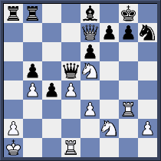

W:

B:

7. White mates/ Black wins
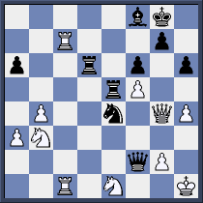

W:

B:

8. White mates/ Black wins
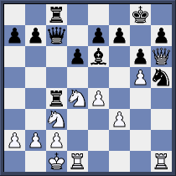

W:

B:

9. White mates/ Black mates
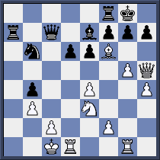

W:

B:

10. White mates/ Black mate/ win
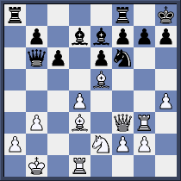

W:

B:

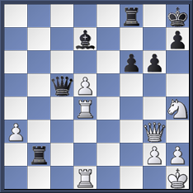

W:

B:

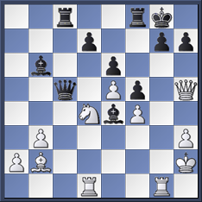

W:

B:

